**Introduction**

Research in the field of human-computer interaction unveils the crucial importance of design within interactive systems. This significance is particularly pronounced in the context of enhancing user satisfaction and operational efficiency. Fitts' Law, a mathematical model estimating the time required to reach a target location, stands as a foundational theory guiding the optimization of user interface design towards more user-friendly interfaces. Particularly in the analysis of commonplace interactive systems such as ATMs, this law gains significant attention. ATMs have become ubiquitous in modern life, serving an essential function by allowing customers to conduct financial transactions independently, without the assistance of bank personnel. Withdrawing cash represents the fundamental transaction that the majority of users perform on a regular basis. It is a fact revealed as a result of studies conducted in different countries such as Israel and Japan that the layout design of ATMs, which includes a high level of user-computer interaction, makes the user's job (Lee & Koubek, 2010).

The user interface of ATMs poses a significant challenge in terms of HCI, especially when it comes to using the touchscreen for choosing withdrawal amounts. To make a selection, users are required to touch options displayed on the screen, navigating through a range of choices for different denominations of money. Such interactions are meant to be straightforward, efficient, and error-free. Nonetheless, the design's failure to adhere to the principles of Fitts' Law introduces usability issues. This oversight in design consideration can significantly hinder the overall user experience, making interactions less intuitive than intended. Furthermore, the design of ATM touch interfaces, which are influenced by Fitts' Law, affects the accuracy and speed of user transactions - which underscores the importance of button size and placement. The ease and accuracy with which users can make selections are significantly influenced by the size and spacing of the touchpad buttons, which represent different money denominations. If the buttons are too small or placed too close together, users may struggle to quickly select their desired option. This can lead to longer transaction times and increase the likelihood of errors. So, the button size and place have to be considered in the context of Fitt's Laws.

The central issue with ATM interface design, influenced by Fitts' Law, revolves around the effect of touchpad target sizes and spacing on user efficiency and accuracy. Utilizing Fitts' Law as an analytical tool allows for an evaluation of how these design elements may hinder user interaction, with recommendations for enhancements aimed at elevating the overall user experience. Such analysis is invaluable, extending beyond the improvement of ATM functionality to serve as a practical example for refining the design of interactive systems through HCI principles. This report seeks to contribute to broader discussions on applying HCI design principles, like Fitts' Law, to identify and remedy design flaws in commonplace technologies, ultimately enhancing both usability and user satisfaction.

**Analysis with Fitts’ Law**

Fitts' Law highlights flaws in the design of ATM interfaces, which negatively affect user performance, especially concerning the touchpad used for selecting withdrawal amounts. The main issue arises from the touch targets being too small and positioned too close to each other. According to Fitts' Law, these factors increase the D/W ratio, which in turn elevates the term Log(1 + D/W), and consequently, the amount of time (T) required for users to make a selection (Yablonski, 2020). This increased selection time can be particularly aggravating in scenarios where quick transactions are crucial. Moreover, the likelihood of errors escalates because targets that are small and closely spaced heighten the risk of inadvertently pressing the wrong button.

We can measure the poor quality aspects of the ATM using specific, suboptimal values. Take, for instance, setting W at 6.5 to represent a small button size, and D at 210 to denote a longer distance across the interface. We also factor in a base time of 0.1 seconds and a movement speed is 0.2.

**Formula = a + b * Log(1 + D/W)**

From the formula (a + b * Log(1 + D/W)), while a selection time of 0.9 seconds might be acceptable under certain conditions, striving for even quicker response times is always beneficial, especially in user interfaces where minimizing errors and maximizing efficiency are key. By enhancing the size and spacing of the buttons, we could further decrease this time, leading to higher customer satisfaction and quicker transactions.

**Proposed Solution**

To address the shortcomings identified in the original ATM touchscreen design, a thoughtful redesign is recommended. This approach fundamentally reevaluates the size and layout of the interactive elements based on the principles of Fitts' Law, aiming to significantly boost the system's ease of use and efficiency. According to Fitts' Law, which predicts the time required to move to and select a target, the Index of Difficulty decreases with the redesign by enlarging the touch targets. Increasing the size of these targets (denoted as ‘W’) simplifies accurate selection, enabling users to carry out their transactions more swiftly and with fewer errors. Additionally, expanding the spacing between these enlarged buttons minimizes the chances of accidental selections, a common frustration among users. While there might appear to be a contradiction between the goal of speeding up interactions and the strategy of increasing the space between targets (‘D’), strategically enlarging the button sizes ensures that overall user experience is improved without compromising on performance. The new interface designed for withdrawing money at ATM can be clearly seen in Figure 1.

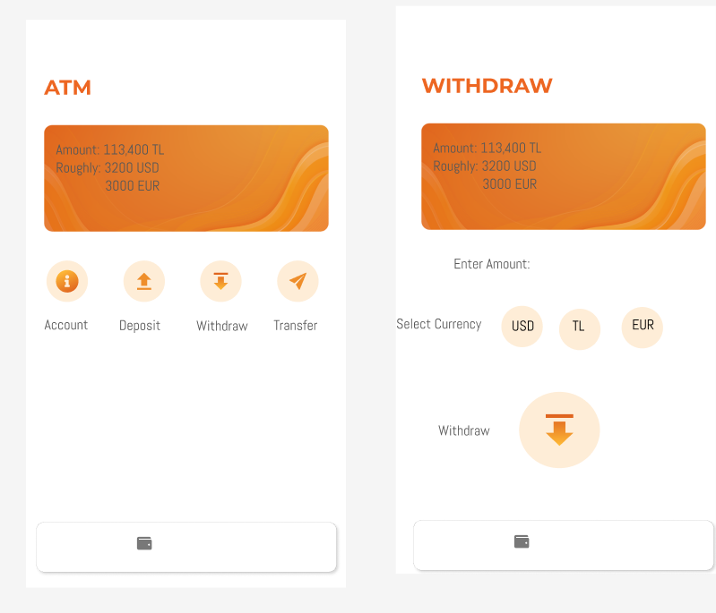

Figure 1

This makeover is underpinned by a holistic strategy that aims to increase the size and improve the positioning of the buttons on the interface. Such adjustments significantly decrease the Index of Difficulty relative to the initial design, thereby facilitating a more intuitive and focused user experience. Expectations from this redesign are twofold: firstly, users should experience reduced selection times; and secondly, a decrease in errors is anticipated. Together, these improvements are likely to culminate in a more positive and effortless interaction with ATMs. By placing a premium on user efficiency and comfort, this revision demonstrates how addressing design flaws through HCI principles can render technology more user-friendly and satisfying.

Figma Link: <https://www.figma.com/file/mvWwXp4ayentfjGi4fqYj9/Untitled?type=design&node-id=0%3A1&mode=design&t=buOmqhGm1hfQtE1o-1>

# References

Lee, S., & Koubek, R. J. (2010). Understanding user preferences based on usability and aesthetics before and after actual use. In *Interacting with Computers* (pp. 530–543).

Yablonski, J. (2020). *Chapter in Laws of UX.* O'Reilly Media.